**BUGY CODE**

**Q: Try to identify any bug and then fix it.**

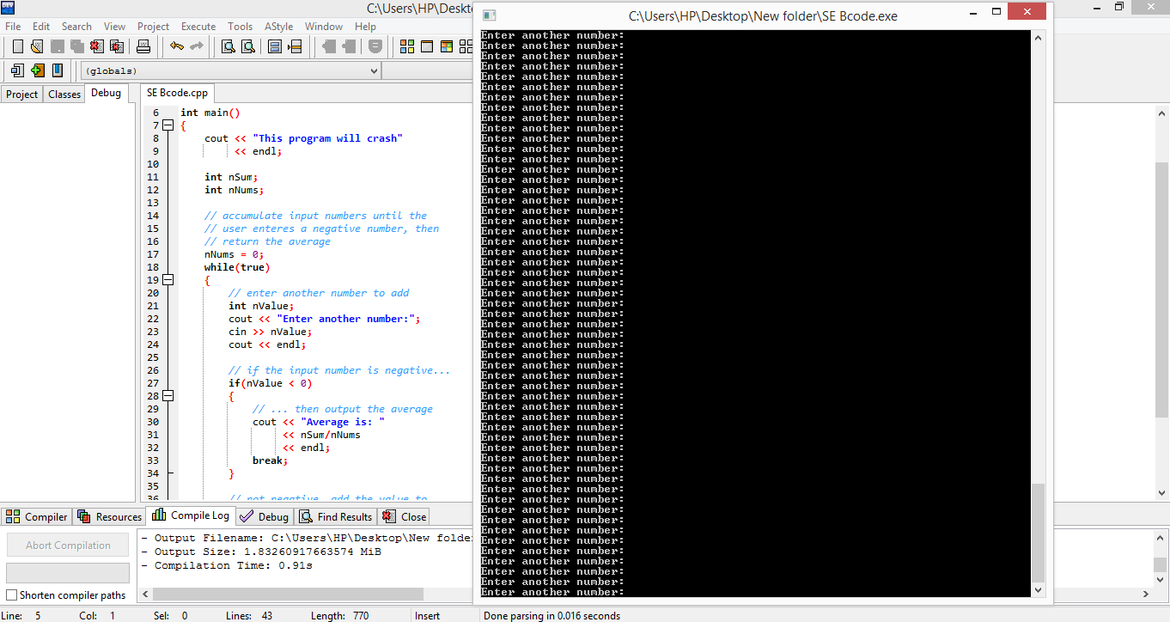

**Ans: Initilize the variables and increment the “nNums”**